121/1
MATHEMATICS ALT A
PAPER 1
JULY 2026

2 ½ Hours
NAME:_____________________________________ADM.NO __________________CLASS____________

ARISE AND SHINE TRIAL 2 EXAMINATION

TERM 2 2026

Instructions to Candidates
- Write your name and index number in the space provided above.
- Sign and write the date of examination in the space provided above.
- This paper consists of TWO sections: section I and section II
- Answer allthe questions in section I and on only five questions from section II
- Show all the steps in your calculations, giving your answers at each stage in the spaces provided below each question.
- Marks may be given for correct marking even if the answer is wrong
- Non-programmable silent calculator and KNEC Mathematical tables may be used, except where stated otherwise.
- The paper consists of 15 printed pages.
- Candidates should check the question paper to ascertain that all the pages are printed as indicated and that no questions are missing.
- Candidates should answer the questions in English

For Examiner’s Use Only
Section I
1 | 2 | 3 | 4 | 5 | 6 | 7 | 8 | 9 | 10 | 11 | 12 | 13 | 14 | 15 | 16 | Total

Section II Grand Total

17 | 18 | 19 | 20 | 21 | 22 | 23 | 24 | Total

SECTION I 50 MARKS
Attempt all questions in this section.

1. Evaluate without using Mathematic Tables or calculators. (4 marks)
$\frac{4 x 6+ \frac{1}{25} ÷0.05+ \frac{1}{5}}{\left(-3\right)÷\left(-6\right)+ \left(23\right)- 6 of 3}$

2. At Merigi senior school, there are 120 boys, 180 girls and 24 teachers. They formed committee comprising of equal number of boys, girls and teachers to steer prize giving Day Activities. Determine the largest number of members of each steering committee that they could form. (3 marks)

3. Simplify completely $\frac{4x^{2}-1}{x^{2} -1} ÷ \frac{2x+1}{x-1 }$ (3 marks)

4. Complete the figure below to show a rotational symmetry of order 3 about point 0. (3 marks)
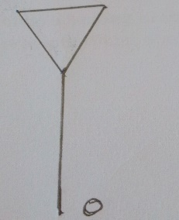

5. A Kenyan bank buys and sells foreign currencies at the exchange rates shown below.
 | Buying (Ksh) | Selling(Ksh)
1Euro  1 US Dollar | 147.56  74.22 | 148.00  74.50
An American arrived in Kenya with 20,000 Euros. He converted all the Euros into Kenyan shillings at the bank. He spent Ksh 2510200 while in Kenya and converted the remaining into US Dollars at the bank. Find the amount in dollars that he received. (3 marks)

6. Find the equation of a line which passes through (5,-2) and is perpendicular to the line 2x – 5y = 3 in the form ay + bx + c = 0 where a, b and c are integers. (3 marks)

7. Find the value of x in equation;
Cos(2x+30⁰) – sin x = 0 (2 marks)

8. Three police posts x, y and z are such that y is 50km on a bearing of 060º from x while z is 70km from y and on a bearing of 300º from x. Using a scale of 1cm represents 10km; draw a diagram to show the position of the police posts. (3 marks)

(b). Determine the distance in km of z from x. (1 mark)

9. A bus travelling at an average speed of 63km/h left a station at 8.15am. A car later left the same station at 9.00 am and caught up with the bus at 10.45 am. Find the average speed of the car. (3 marks)

10. The equation of a curve is given by y = x³ – 6x² + 16x. Find the equation of the tangent at point (1, 4) (3 marks)

11. The masses of two similar solids are 800g and 12500g. If the surface area of the smaller one is 216cm², find the surface area of the larger solid. (3 marks)

12. The size of each interior angle of a regular polygon is seven times the size of the exterior angle. Find the number of sides of the polygon. (3 marks)

13. Solve for x and list the integral values in the linear inequality
1 + $\frac{1}{2}x≤2x-\hat{3 }<$x + 2 (3 marks)

14. Solve for x in the equation;
25^{x} – 5^{2x-1} = 500 (3 marks)

15. The position vectors of A, B and C are$\left(\begin{aligned}-4 \\ 6\end{aligned}\right)$,$\left(\begin{aligned}-8 \\ 2\end{aligned}\right) and \left(\begin{aligned}2 \\ a\end{aligned}\right)$ respectively vector CA is parallel to vector OB. Determine the value of a. (3 marks)

16. The figure below shows part of triangular prism ABCDEF. Complete the prism and measure the length of AF. (4 marks)

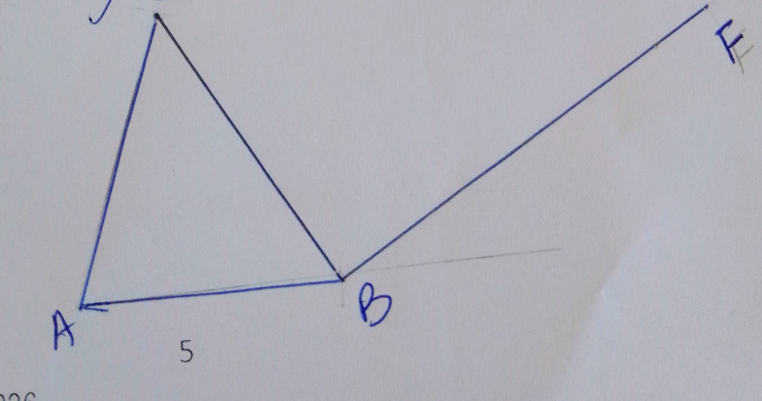

SECTION II (50 MARKS)
Attempt only FIVE questions in this section
17. The frequency table below shows a daily wages paid to casual workers by a certain company.
Wages in shillings | 100-150 | 150-200 | 200-300 | 300-400 | 400-600
No. of workers | 160 | 120 | 380 | 240 | 100
(a). State the class in which the median wage lies (1 mark)

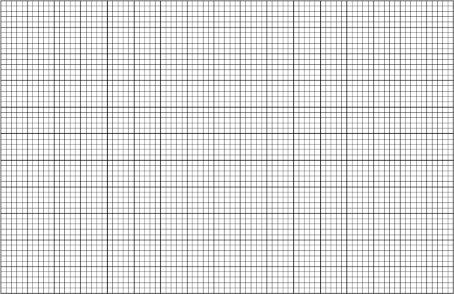
(b) Draw a histogram to represent the above information. (4mks)
(c). Use the histogram to (i) determine the median wages. (3 marks)

(ii) determine the number of workers who earns sh.450 or less per day. (2 marks)

18. Triangle PQR has vertices P(5,5), Q(10,10) and R(10,15) undergoes reflection to triangle P^{I}Q^{I}R^{I} whose vertices are P^{I}(1,7),R^{I}(6,17)
(a)(i) On the grid provided draw triangle PQR. (1 mark)
(b)(i) Locate co-ordinate of Q^{I.} (1 mark)
(ii) Draw triangle P^{I}Q^{I}R^{I} (1 mark)

(c) Draw the mirror line and determine its equation in the form y = mx+c. (3marks)

(d) Triangle P^{II}Q^{II}R^{II} is the image of triangle P^{I}Q^{I}R^{I} under reflection on y axis
Draw triangle P^{II}Q^{II}R^{II} (2 marks)

(e) Describe fully a single transformation that maps triangle PQR onto triangle P^{II}Q^{II}R^{II}. (2 marks)

19. A minor sector of a circle of radius 28cm includes an angle of 135o at the centre
(a) Convert 135º into radians. Hence find ;
(i) the area of the sector. (3 marks)

(ii) the length of the minor arc. (2 marks)

(b) The sector is folded to form a right circular cone. Calculate the;
(i) Radius of the circular base. (2 marks)

(ii) Volume of the cone (Take $π=\frac{22}{7}$ ) (3 marks)

20. ABCD is a trapezium in which AB is parallel to DC. BD=10.9cm, DC=6.4cm and $∠$BAD = 45º and $∠$BDC= 38º (3 marks)

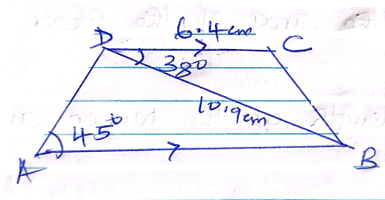
Calculate correct to 1 decimal place;
- The length of BC. (3 marks)

- The length of AB (3 marks)

- The perpendicular distance of D from AB. (2 marks)

- The radius of a circle that passes through the points B, C and D (2 marks)

21. (a) The table below shows some values of the function y = x²+2x-3. Complete the table (2 marks)
x | -6 | -5.75 | -5.5 | -5.25 | -5 | -475 | -4.5 | -4.25 | -4.0 | -3.75 | -3.5 | -3.25 | -3
y | 2 | 8.56 |  | 14.06 |  | 10.06 | 8.25 |  | 5 |  | 2.25 | 1.06 | 0

(b). Using the mid-ordinate with six ordinates to estimate the area of the region bonded by the curve
y = x²+2x-3 and the lines y = 0, x = -6 and x = -3 (3 marks)

(c) By integration find the area of region in (b) above. (3 marks)

(d) Assuming that the area determined by integration to be the actual area. Calculate the percentage error in using the mid-ordinate rule. (2 marks)

22. (a) Given that $\left(\begin{matrix}3 & x \\ x+1 & 2\end{matrix}\right)$ and B = $\left(\begin{matrix}1 & 2 \\ 3 & 0\end{matrix}\right)$, find the values of x for which AB is a singular matrix.
(4 marks)

(b) Koech bought e exercise books and 5 pens for a total of Ksh.165. If Koech had bought had bought 2 exercise books and 4 pens, he would have spent ksh.45 less. Taking x to represent the price of an exercise book and y to represent the price of a pen
(i) Form two equations to represent the above information (1 mark)

(ii) Use matrix method to find the price of exercise books and that of a pen. (3 marks)

(iii). A teacher of a class of 36 students bought 2 exercise books and 1 pen for each student. Calculate the total amount of money the teacher paid for the books and pens. (2 marks)

23. (a) Using a pair of compasses and ruler only, construct.
(i) triangle ABC in which AB = 5cm, angle BAC= 30º and angle ABC = 105º (3 marks)

(ii) a circle that passes through the vertices of the triangle ABC. Measure the radius. (3 marks)

(iii) the height of triangle ABC with AB as the base measures the height. (2 marks)

(b) Determine the area of the circle that lies outside the triangle correct to 2 decimal palaces. (2 mark)

24. The equation of a curve is y = (x²+1) (x-2)
(a) Find (i) the x – intercept of the curve. (2 marks)

(ii) the y-intercept of the curve. (1 mark)

(b) (i) Determine the stationary points of the curve. (3 marks)

(ii) For each point in b (i) above, determine whether it is a maximum or minimum (2 marks)

(c) Sketch the curve (2 marks)

